**Challenge Name: HexHunt**

**Challenge made by:** Yash Dinesh Singh

**Description:**

Unravel the mystery of the hexadecimal string on a specialized search engine to find the IP address associated with one of the top 3 organizational devices, but beware of the trap.

**Flag**: hacker{202.46.129.76}

**Files:** "**input.txt**" – contains the hex code to be searched

**Walkthrough:**

One of the famous specialized search engine for devices is **Shodan** (<https://www.shodan.io>).

After logging in, search up the hexadecimal string on Shodan.

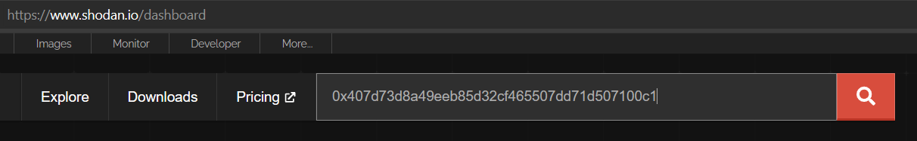

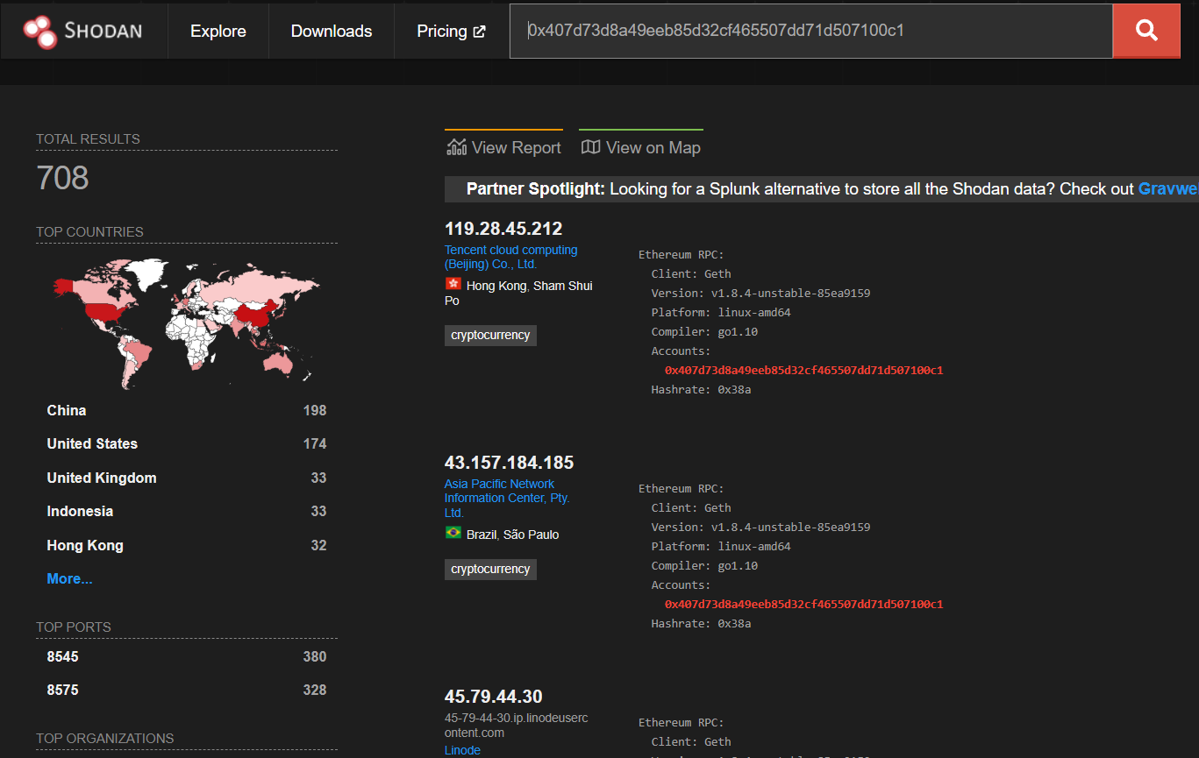

Since there are hundreds of devices you might find it difficult to check through all of them. If you notice, below ‘TOP ORGANIZATIONS’ is a section ‘TOP PRODUCTS’, which includes ‘Honeytrap’. This is the trap mentioned in the challenge description.

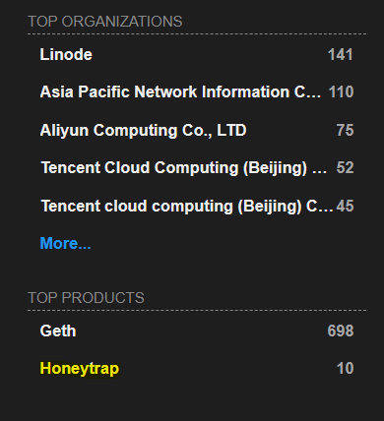

Click on it, and you will see many organizations but all of them have 1 device => 1 IP address. The flag is the IP address of the device of 3rd highest organization.

